

ICOP

(Integrated Cloud Oriented Platform)



Contents

1. Introduction 2
   1. Purpose 2
   2. Important Points 2
2. Steps to Submit Re-Evaluation Form 3
3. Steps to View List of Students Who fill Re-Evaluation form 6



# Steps to Submit Re-Evaluation Form

1. On accessing the URL [**https://hsbtehry.in**](https://hsbtehry.in/) below mentioned login screen will be displayed:

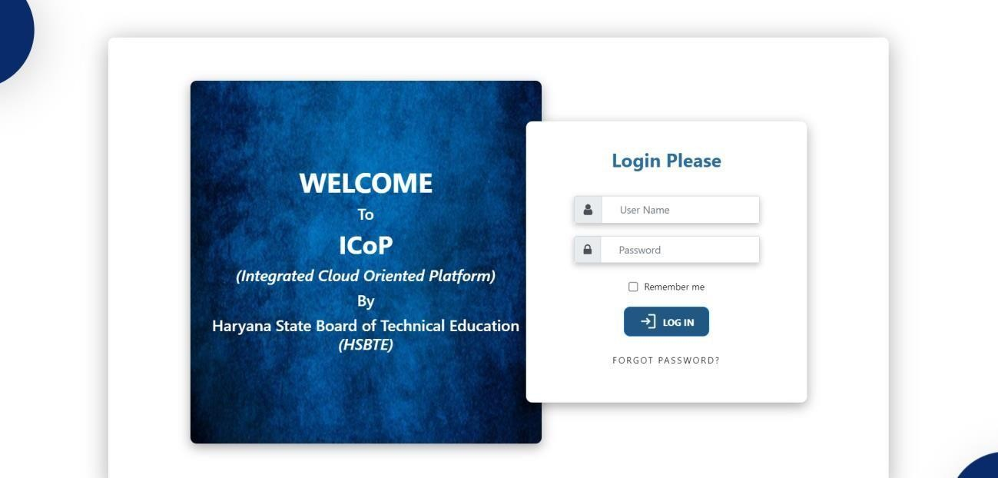

Figure 1 : Login Screen

1. Welcome screen will be displayed. Under Manage Students There is Option of Re-Evaluation Go there.

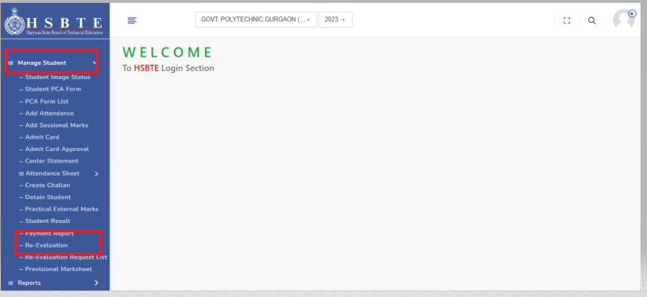

Figure 2 : Welcome Screen



1. Follow path Student Management->Manage student -> Re-Evaluation Form
2. Now add your RollNo. And Click on Search Button

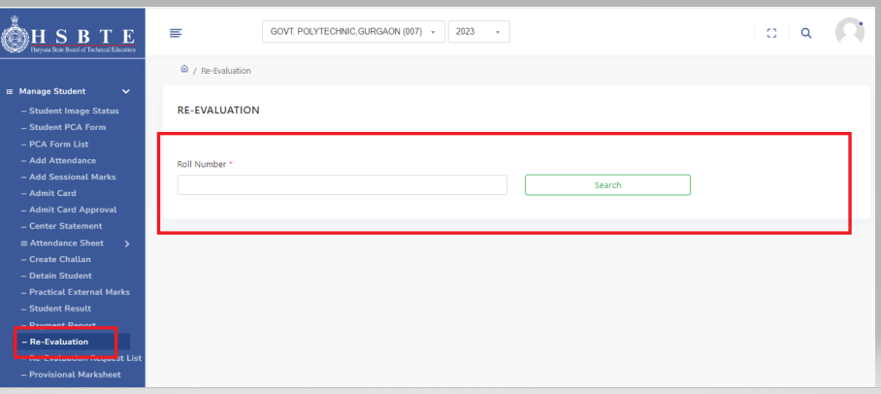

Figure 3 : Path for Student Re-Evaluation Form

1. After Clicking on Search button All Your Subjects are Shown

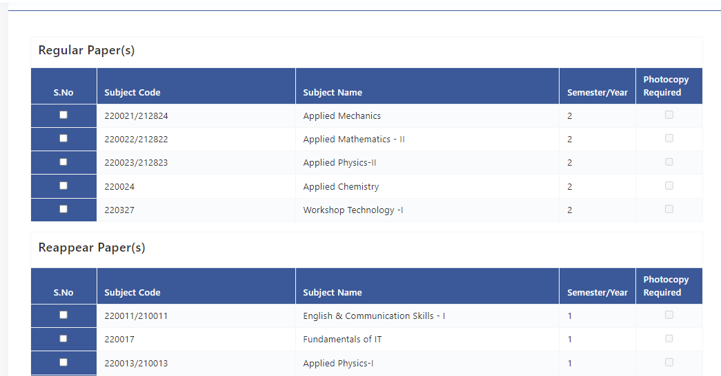

1. From Here Select All the subjects Which you want to fill for Re-Evaluation. Fees will be calculated per subject and according to physical copy required.
2. Now If you Select Subject only then your Fees wil be 600

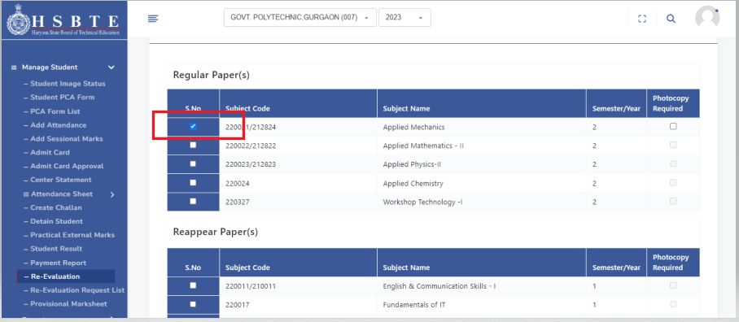

1. When You Select Subject + Photocopy then your fess will be 1000. After Selecting all the subject Click on Submit .

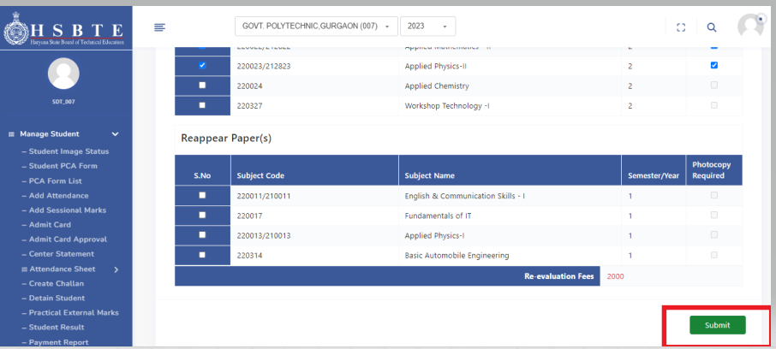

1. After Submission following Screen will be shown

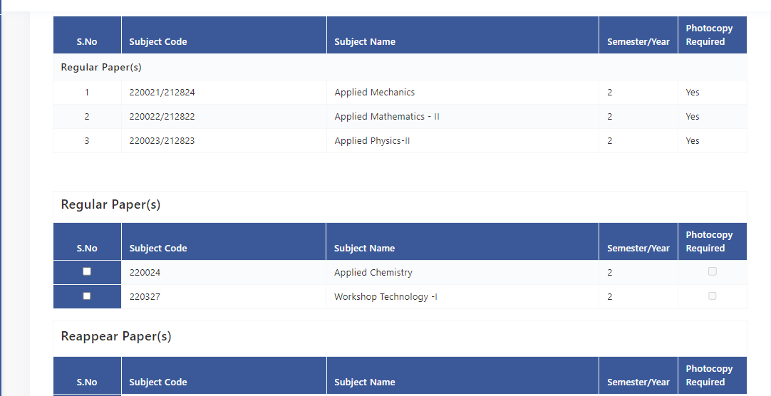

1. In this Screen Your Selected Subjects will be Shown And also Another Subjects will be shown If you .If you want to add more then you can add But not Delete the previous added subjects . After selecting all the subjects Again click on Submit Button .
2. When You click on Submit button this type of Notification will be shown.

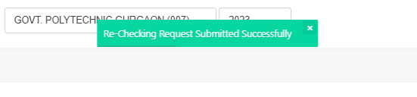

1. Now Your Form Is submitted Successfully.
2. Once form submitted will be directly visible to concerned TMC.



# Steps to View List of Re-Evaluation Forms

1. Follow the Path Student Management->Manage student -> Re-Evaluation Request List.

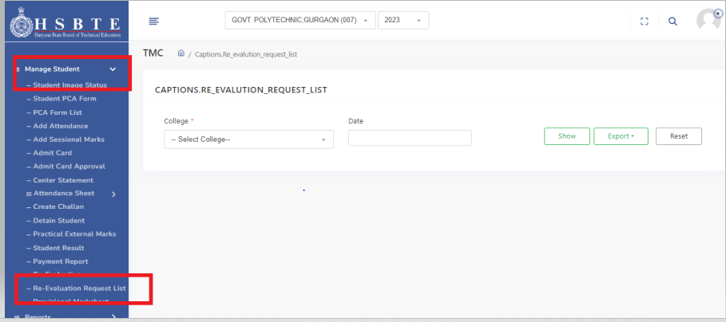

1. From College Dropdown Select your college name And click on Show.

This Type of list will be shown

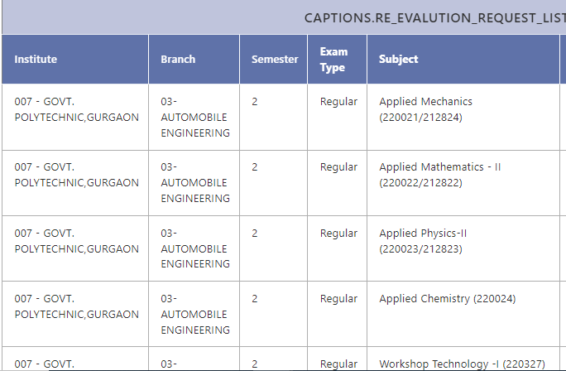

1. From Here Colleges can see the list of students who fill Re-Evaluation Form.